**Educational Objective:**

The objective of this lab is to gain a better understanding of Diode clipping circuits and use of MultiSim for simulation.

**Pre-Laboratory:**

1. Read the laboratory.
2. Sketch vin and vout for the circuit in Figure 1.

Section 1: Rectifier circuit – sketching the output.

*Use the ModelSim Simulator to graph the input and output waveforms for each circuit below.*

* 1. Open MultiSim.

NOTE: Engineers are constantly faced with the challenge of using new software tools. Not only do they need to teach themselves how to use the new tools, the technicians that work for them will look to the engineer for help with the new tool. Engineering tools, unlike most modern software, tend to be complicated and actually need instruction. Fortunately most vendors realize this and provide the needed help document.

* 1. Enter the schematic in Figure 1 and save the design using the instructions below.
     + Open “Getting Started” pdf under the Help menu.
     + In the Table of Contents, find the instructions on schematic capture. Read this section. Stop reading at Simulation.

|  |
| --- |
|  |
| Diode Rectifier Circuit |

Figure 1

* + - Select “Component” in the Place Menu.
      1. Change the group selection from “All Groups” to “Sources” and the family to “SIGNAL_VOLTAGE_SOURCES”. Find and place the AC_Voltage. Double click on the source and change the peak voltage to 5V.
      2. While still in the “Sources” group change the family to POWER_SOURCES. Find and place GROUND.
      3. Change the group selection to “Diodes” and the family to “DIODE”. Find and place the 1N4004G.
      4. Change the group to “Basic” and family to RESISTOR. Find and place a 1.0k resistor.
    - Wire the design so it looks like Figure 1. Double clicking on a component lets you change what is displayed.
      1. Optional - use the Display tab and select “Use component-specific visibility settings”
      2. Use the Label tab to change the reference designator so it is the same as the figure.
    - Double click on the node (wire) to the left of D1. Enter the “Preferred net name:” of “vin” and click “Show net name”. Repeat for vout.
  1. Use the transient analysis to plot vin and vout using the procedure below.
     + Under the Simulation tab, select Analyses and simulation. Then select Transient.
     + Select the Analysis parameter tab and then
       1. Enter 0 for TSTART.
       2. 2E-3 for TSTOP (this is 2ms).
     + Select the Output tab and then
       1. Add V(vin) and V(Vout).
       2. Click Run on the bottom of the window.

Note: The ability to sketch vout by hand can be difficult but is very important. You might ask why when the computer does it so quickly and easily but is the display correct? An error in the schematic entry can easily produce the wrong results and be very embarrassing if you provide an erroneous plot as fact to your boss. The steps below will help you make a quick hand sketch so you can verify the simulation results. The simulator does the heavy lifting producing exact results after thousands of calculations. It is your job to make sure the results make sense.

* 1. Verify V(vin) on the plot.
     + Vin should be 5V peak or 10V peak to peak.
     + The period should be 1/1KHz or 1ms.
  2. Verify V(Vout) is a bit more complex. Here is a procedure.
     + Write a KVL equation for the circuit: vin + vd + i*R = 0. i*R is also positive because the current is drawn in the direction the diode will conduct (CCW).
     + Next solve for vd + i*R. The equation becomes: -vin = vd + i*R.

Note: For the diode to conduct vd + i*R must be > 0.7V.If vd + i*R must be >0.7 than –vin must also be greater than 0.7V.

* + - Replace vd + i*R with 0.7V. The result, –vin > 0.7V or vin < -0.7V for the diode to conduct.

Note: -0.7V becomes an important switching point for the diode. When vin is less than -0.7V the diode conducts, when vin is greater than -0.7V the diode is off.

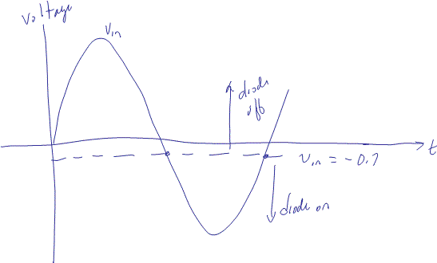

Note: The final step is to draw the circuit when the diode is off and again when the diode is on.

* + - Draw a circuit with the diode off (open circuit) above the vin = -0.7 line and a circuit with the diode on (0.7V battery) below the vin = -0.7 line.

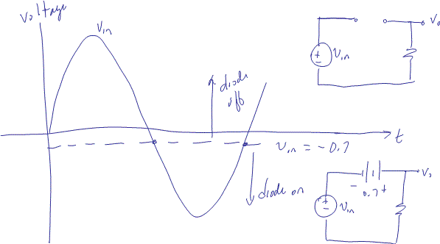

* + - Examine each circuit and determine the output equation. In the top circuit vo = 0V. In the bottom circuit vo = vin + 0.7V.
    - The final step is to draw the output using the output equations.

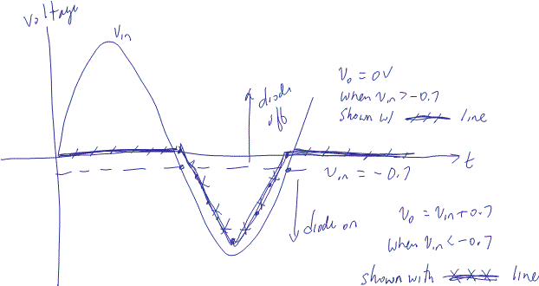

* 1. You should never ask your professor or boss at work “is this right”. By verifying the simulation with circuit theory, you know it is right!
  2. Get a sign-off when you are sure your simulation is correct! Sign-off sheet at the end of the lab.

Section 2: Clipping circuit – sketching the output.

* 1. Enter the schematic in Figure 2
     + The new component is DC_POWER found in the Source group and POWER_SOURCES family.
     + Make sure the components are displayed as shown in Figure 2.
     + Label the input and output nodes as shown in Figure 2.

|  |
| --- |
|  |
| Diode Clipping Circuit |

Figure 2

* 1. Use Transient to plot vin and vout.

Note: Hopefully you are thinking “is the right?” This is natural for engineers. So make a sketch! This is not an accurate graph. That is what the computer is for! Just a sketch to see if you entered everything correctly and if the program is working as expected. One version of PSpice provided by another vendor failed to use Ohm’s Law correctly. Your boss will expect you to find those errors.

* 1. Verify V(vin) on the plot.
  2. Verify V(Vout) is a bit more complex. Repeat the procedure above with the help provided below.
     + Write a KVL equation for the circuit: Notice both vin and vd are positive because of the direction of the diode. The current should be draw so the diode conducts.
     + Solve for vd + i*R and put vd + i*R on the right hand side of the equation.

Note: vd + i*R must be > 0.7 for the diode to conduct. Put differently both the right hand side and left hand side of the equation must be greater than 0.7 for the diode to conduct.

* + - Replace vd + i*R with 0.7 and the equals with a > sign. Solve for vin. Remember: if you multiply the equation by -1 you must change the inequality.
    - Sketch vin in Figure 3.
    - Draw a dotted line for the vin value you found that causes the diode to turn on (conduct).
    - Draw the circuit replacing the diode with a 0.7V battery (on).
    - Write an equation for vo using the circuit and sketch vo on the sketch of vin.
    - Draw the circuit replacing the diode with an open circuit (off).
    - Write an equation for vo using the circuit and sketch vo on the sketch of vin.

|  |
| --- |
|  |
| Input and Output waveforms |

Figure 3

* 1. The two quick sketches together are used to verify the simulation. You should never ask your professor or boss at work “is this write”. Sorry to repeat the statement (and misspelling) but it is important.
  2. Get a sign-off when you are sure your simulation is correct!

Section 3: Clipping circuit – design

* 1. Create a clipping circuit with the same components used in Figure 2 to create the input/output waveform in Figure 4. The following rules apply:
     + Use the same components used in Figure 2.
       1. The peak value of V1 can be changed.
       2. Any of components can be rotated and/or moved.
       3. The value of V2 can be changed.
     + Since the peak value is so high you can assume an ideal diode.

Hint: In design work we often are presented with a problem and are able to find circuits that provide a solution. Figure 5 was scanned from your textbook. One of the circuits on this page solves this problem. Your job as an engineer is to pick the correct circuit and component values. As the peak voltages are so high you can assume an ideal diode. 0.7V is not significant when the supply voltages are 100s of volts.

* + - Once a solution is found verify the output using KVL just like we did in section 2. For ideal diodes we still solve for vd + i*R and put vd + i*R on the right hand side of the equation. The change comes in when we replace vd + i*R with 0V. The equals sign is still changed with a > sign.

|  |
| --- |
|  |
| Diode Clipping Circuit |

Figure 4

**

Figure 5

1. *Sign-offs Name*

Section 1: rectifier

|  |  |  |
| --- | --- | --- |
|  |  | / / |
| Signature |  | Date |

Section 2: clipping

|  |  |  |
| --- | --- | --- |
|  |  | / / |
| Signature |  | Date |

Section 3: design

|  |  |  |
| --- | --- | --- |
|  |  | / / |
| Signature |  | Date |

1. *Post Lab Work*:
   1. Cover page with name and lab date/time.
   2. Provide a summary,
   3. Sign off page,
   4. KVL Verification of section 3 design work, circuit diagram and output waveform.